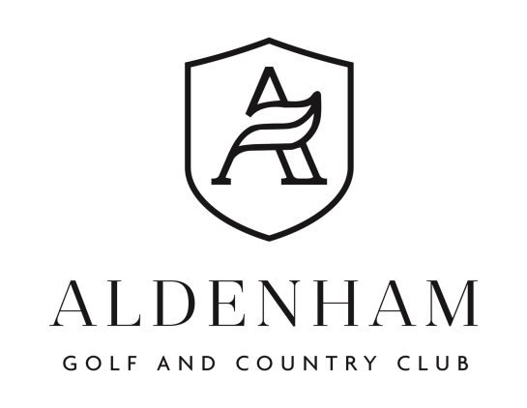

Junior Open
Tuesday 2nd September 2025
18 Holes - Church Course
14 – 18 years of age
10:30 Arrival for registration
11:00 Continental breakfast
12:02 Two Tee Start 1st & 10th
Halfway House Refreshments & Snacks, Prize Giving and Presentation with evening meal
To enter please complete the entry form below and return to sales@aldenhamgolfclub.co.uk or post to Junior Open, Aldenham Golf & Country Club, Church Lane, Aldenham, Herts, WD25 8NN
Closing Date for Entries 18th August 2025
An official WHS handicap index is required. The details below will be used to find your WHS index.
Maximum playing handicap 54,
____________________________________________________________________________________________

NAME & SURNAME _______________________________________________

CDH# _______________________________________________

HOME CLUB _______________________________________________
MOBILE _______________________________________________
EMAIL _______________________________________________

RELATIONSHIP STATUS TO JUNIOR ____________________________________________
GUARDIAN FULL NAME ____________________________________________
MOBILE ________________________________________________
EMAIL ________________________________________________

Medical Information
Please list any medical conditions, allergies, or medications we should be aware of:
____________________________________________________________________________
____________________________________________________________________________
Is the participant currently taking any medication?
☐ Yes ☐ No If yes, please specify: _____________________________________________
Does the participant have any dietary requirements or restrictions?
☐ Yes ☐ No If yes, please specify: _____________________________________________
Emergency Consent
In the event of illness or injury, I authorise the organisers to act on my behalf where immediate medical treatment is required.
☐ I give consent ☐ I do not give consent
Photography & Media Consent
Do you consent to your child being photographed or filmed during the event for use on club social media, newsletters, or promotional materials?
☐ Yes ☐ No
Parent/Guardian Declaration
I confirm that the above information is correct, and I give permission for the named junior to take part in the Junior Open at Aldenham Golf & Country Club. I understand that every care will be taken to ensure the safety and welfare of participants, in line with the club's safeguarding policies.

Signature of Parent/Guardian: __________________________

Date: ____________________

